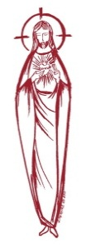
SACRED HEART PARISH

Sacred Heart Parish Founded 1814, The First Catholic Parish in the STate of New Jersey

Sacred Heart Church, 343 South broad Street, Trenton, New Jersey 08608

Holy Cross Church, 233 Adeline Street, Trenton, New Jersey 08611

ALL ARE WELCOME

Whatever your present status in the Catholic Church, whatever your current family or marital situation,

Whatever your past or present religious affiliation, whatever your personal history, age, background, or

race, whatever your own self-image or esteem, you are invited, welcomed, accepted, loved and

respected at the Parish of the Sacred Heart.

PASTOR

Rev. Msgr. Dennis A. Apoldite
frdennis@trentonsacredheart.org
PAROCHIAL VICAR
Rev. Charles Muorah
Rev. Marcin Kania, weekend Polish Mass
Felician Residence for Clergy
233 Adeline Street, Trenton, New Jersey 08611
609-393-4826 ext. 108 for Fr Charles
DEACONS
John Grussler and Dr. Christian Nnajiofor

Business Manager / ADMINISTRATIVE ASSISTANT
John DeSantis: secretary@trentonsacredheart.org
coordinator of religious education
Mary Tovar: reled@trentonsacredheart.org
COORDINATORS OF SACRED MUSIC
Natalie Megules ~ 609-575-6484
Rupert Peters ~ Gospel Mass 609-442-7871
MAINTENANCE DEPARTMENT
Frank Rios
Trustees
Jack Breuer and Ellieen Ancrum Ingbritsen,

OFFICE HOURS

9:00am – 4:00pm Monday – Friday

SACRED HEART PARISH OFFICE

343 South Broad Street, Trenton, NJ 08608

Phone: (609) 393-2801 ~ Fax: (609) 989-8997

WEB PAGE:

www.trentonsacredheart.org

CEMETERY RECORDS
Contact The Office of Catholic Cemeteries at 609-394-2017 or DirectorofCemeteries@DioceseofTrenton.org

SACRAMENTAL RECORDS
Sacred Heart Church, Saint John’s Church, Saint Francis Church, Saints Peter and Paul Church, Saint Stanislaus Church, Holy Cross Church, Blessed Sacrament Church, Our Lady of Divine Shepherd Church, Blessed Sacrament/Our Lady of Divine Shepherd Parish and Divine Mercy Parish.

Liturgy Schedule

Sacred Heart
Monday, Tuesday, Wednesday and Friday
12:10 Noon
Saturday Evening 5:15 PM
Sunday Morning 9:00 and 11:15 AM
HOLY CROSS
Monday, Thursday and Friday 8:00 AM
First Friday 6:30 PM Polish Mass
Saturday Evening 4:00 PM
Sunday Morning 10:00 AM Gospel
12:00 Noon Polish
For each Holy Day please reference the bulletin

SACRAMENTS
BAPTISM
Please call the Parish Office at least one month in advance.

RECONCILIATION

Every First Friday following the 12:10PM Mass SHC

Saturday afternoon ~ 4:30 to 5:00 PM SHC

Every Saturday from 3:30 to 3:50 PM HCC

Every Sunday 9:30 to 9:50AM HCC

and by appointment.
EUCHARISTIC ADORATION
First Saturday of the Month 2:30 to 3:30 pm
in Holy Cross Church
MARRIAGE
Please call the Parish Priest at least one year in advance to set up initial meeting and to confirm a wedding
date and time.
ANOINTING OF THE SICK
Please call the Priests any time 609-393-2801.
COMMUNION TO THE HOMEBOUND
Call the Parish Office to schedule home visit.
CONSIDERING PRIESTHOOD?
Email: Vocations@DioceseofTrenton.org

Easter Sunday of the Resurrection of the Lord
April 9, 2023

MASS INTENTIONS
Saturday, April 8 ~ EASTER VIGIL
8:00 pm SHC ~ People of the Parish
Sunday, April 9 ~ EASTER SUNDAY
6:45 HCC Polish ~ Special Intentions
9:00 SHC ~ Special Intentions
10:00 HCC ~ Special Intentions
11:15 SHC ~ Special Intentions
12:00 HCC Polish ~ Special Intentions
Monday, April 10
8:00 am HCC ~ No Mass
12:10pm SHC ~ No Mass
Tuesday, April 11
12:10 pm SHC ~ Jack Kostrzewa
Wednesday, April 12
12:10 pm SHC ~ People of the Parish
Thursday, April 13
8:00 pm SHC ~ Dolores Krysztofik
Friday, April 14
8:00 am HCC ~ Deceased Priests of the Parish
12:10pm SHC ~ Deceased Religious who taught in our schools
Saturday, April 15
4:00 pm HCC ~ Shelby Rowe
5:15 pm SHC ~ Mary Ann Cook
Sunday, April 16 ~ DIVINE MERCY SUNDAY
9:00 SHC ~ Holy Name Society
10:00 HCC ~ W. Dajczak
11:15 SHC ~ People of the Parish
12:00 HCC Polish ~ Jan Konecki
OUR SICK LIST
Dawn Chia, Mark Friedman, Chris Heulitt, Robert Leighton, Patrick Leighton, Alexander A. Ladnyk, Kelly Nitti, Deacon John Grussler, Lauren Clayton, Joseph Edralin, Margie Tiongson, Pat Tagliaferri, Kevin, Vincent Cooper, Jr., Gail Ladnyk, Leo Genovesi, Sloane Donnelly, Richard Buckley, Tony Ragolia, Barbara Burrows, John Matthews, Pam Yuhas, Robert Mahon, Charles Burrows, Dorothy Amoroso, Maryann Sullivan, Regina Friedman, Rita Mich, Stanley Winowicz, Greg Schafer, Jack Hardiman, Paul Leighton, Amy Birk, Julia Grazioli, Matt and Leona Tydryszewski.

OUR DECEASED
Louis Millington, Jr, Helen Potash, Joseph Farruggio, and our friends at South Village, Riverside Nursing and Rehabilitation Center, Mill House and Waters Edge.
MINISTRY SCHEDULE

Saturday, April 8 EASTER VIGIL
8:00 pm SHC ~ Msgr. Dennis L. EM.
Sunday, April 9 EASTER SUNDAY
9:00 SHC ~ Msgr. Dennis L.E Wengryn Em A&C Cruz
10:00 HCC ~ Fr. Charles F Kollie EM O Nnadi
11:15 SHC ~ Msgr. Dennis L. J. Laurenti Em J. Diaz, S. Jurczynski
12:00 HCC Polish ~ Fr. Marcin L.

Saturday, April 15
4:00pm HCC ~ Fr Charles L. V Zielinski Em. C Benitez
5:15pm SHC ~ Msgr. Dennis L.L Seabrook EM. J&T Breuer
Sunday, April 16 DIVINE MERCY SUNDAY
9:00 SHC ~ Msgr. Dennis L.R Micharski Em E Wengryn E Wirzburger
10:00 HCC ~ Fr. Charles L O Nnadi EM V Kamah
11:15 SHC ~ Msgr. Dennis L. M. Rogers Em T. Rizzuto, M. Tovar
12:00 HCC Polish ~ Fr. Marcin L.

WEEKLY COLLECTION
The collection for last weekend amounted to $10,0239.00. Thank you for your continued support of our parish.

2023 ANNUAL CATHOLIC APPEAL UPDATE
Goal: $33,000.00
Pledged: $32,,800.00 (98% of Goal)

READINGS FOR THE WEEK
Easter Sunday of the Resurrection of the Lord
Sunday Acts 10:34 43; Col 3:1-4 Jn 20:1-9
Monday Acts 2:14, 22-33; Mt 28:8-15
Tuesday Acts 2:36-41; Jn 20:11-18
Wednesday Acts 3:1-10; Lk 24:13-35
Thursday Acts 3:11-26; Lk 24:35-48
Friday Acts 4:1-12; Jn 21:1-14
Saturday Acts 4:13-21; Mk 16:9-15

Easter Vigil Liturgy
8:00 pm at Sacred Heart Church
~~~
Easter Sunday
April 9th
Sacred Heart Church 9:00 am and 11:15 am
Holy Cross Church 6:45 am (Polish) 10:00 am (Gospel Mass) 12:00 noon (Polish)

The Parish Office will be closed
Holy Thursday, April 6th and
will open on Easter Tuesday, April 11^{th.}

HAPPY EASTER
We pray that during this Easter Season, the Risen Lord will grace you with renewed hope, lively faith and sincere love. May all the joys of Easter be with you and your loved ones, as together we celebrate the great Alleluia!
Happy Easter,
Msgr. Dennis, Fr. Charles and Staff

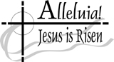

EASTER MORNING PRAYER
As the world sings triumphant cries to heaven over death that You conquered, help us, Lord, tomorrow as well, when the dresses are put away and the candy is all eaten and on with life we go let us not forget. The celebration of Your Resurrection over death is a celebration of life that should continue well beyond the sunrise service and the music, rehearsed for days prior; it is beyond the sign of spring beyond the lily beyond new lambs grazing in open fields. Resurrection is a daily celebration over fear; man's greatest and most powerful enemy. Fear of tomorrow, fear of our yesterdays, fear of what shall become of our young our old our unborn. Resurrection is replacing fear with physical action. This alone, the most touching and profound of Your signs that fear is dead and belief in You brings, not just hope but life. What better living parable could You have brought? All fear death. All. Even in the garden, You took on our fear if for only moments, it was as real as our fears can be real and You knew then that this single enemy must be destroyed. You sacrificed Your life to conquer fear and so much more. I shall cling to this now, and the tomorrows given me. Amen.

EASTER DUTY
The privilege of receiving the Eucharist at least once a year should be fulfilled from the First Sunday of Lent, February 26th to Trinity Sunday, June 4th .
DATES TO REMEMBER
FIRST HOLY COMMUNION
All are invited to attend our parish First Holy Communion Mass on April 29th at 10:00am.

SACRAMNET OF CONFIRMATION
You are also invited to attend the Ceremony for the Sacrament of Confirmation to be administered on May 9, 2022 at 6:00 pm.

PARISH MAY CROWNING
Our annual May Crowning of the image of Mary will be held on Sunday, May 7th following the 11:15 am Mass. Our Religious Education Families are invited to attend the Family Mass and then gather outside at the statue of Our Lady for the annual crowning.

SACRED HEART PARISH PICNIC
Our Parish Picnic will be held
On the grounds of the CYO of Mercer County
453 Yardville-Allentown Rd., Yardville, NJ
July 9, 2023 – 1:00-5:00PM
MASS will be Celebrated at 1:15PM
More information will follow

21st ANNUAL BLUE MASS
CELEBRATION OF LAW ENFORCEMENT
The 21st Annual Mass and Celebration of Law Enforcement will be held at 10:30 a.m. April 13, the Thursday of Easter Week, in St. Robert Bellarmine Co-Cathedral, 61 Georgia Rd., Freehold. Men and women of all faiths are invited to attend this annual celebration for which Bishop David M. O’Connell, C.M., will be the principal celebrant and homilist. Those who are unable to attend the Blue Mass are invited to watch via Livestream, which will be made available on the diocesan YouTube channel.
WHEN SHOULD A PRIEST BE CALLED
FOR THE SICK?
Among the seven sacraments, one especially intended to strengthen those who are ill—the Anointing of the Sick. Over the centuries this sacrament was conferred more and more exclusively on those at the point of death and as a result, it received the name “Extreme Unction.” Consequently, hospital workers and family members would summon a priest at the last moments of a person’s life—often when he or she was unconscious. Even if a priest responded immediately, he might arrive after the person died. The person would not have had the opportunity to confess, receive the Apostolic Pardon, Anointing and Holy Communion—the greatest spiritual comfort the Church can offer at such a time!

Consider how beneficial it is for the sick to be conscious when receiving the sacraments—aware of the presence and grace of God. At times, family members fear that the arrival of a priest would alarm or upset their loved one at the prospect of the “last rites.” Priests not unaware of this concern, do their best to place the sick person at ease.

While the anointing serves to comfort the dying, it is not only for those at the point of death. It is also intended to help the chronically ill, the elderly in a weakened condition, and those facing serious surgery. It is also intended for children who are seriously ill or facing major surgery. Catholics should feel free to request the sacrament before being admitted to the hospital. This can be done after Mass or by a visit to the parish office. One might also take advantage of the occasional communal celebration of Anointing that may be held in a parish.

The sacrament can be administered more than once even during the same illness if a person’s condition became more serious. The relatives of someone who is ill at home, in a hospital or nursing home should not wait until the last moments of a person’s life before calling a priest.
ST ANTHONY OF PADUA PARISH
THEODORE DUBOIS CONCERT
St. Anthony of Padua’s Music Ministry presents their Spring Concert featuring Duboisʹ Seven Last Words of Christ and Mozart’s Regina Coeli on Friday, April 21, 2023 at 7:30 p.m. at St. Anthony of Padua Church, 121 Bridge Avenue, Red Bank. (732-747-0813). Admission is a Free Will Offering. Church is handicapped accessible.

ALS PRAYER GROUP AVAILABLE
Lou Gehrig’s disease (ALS) is a neurological disease with no known cure. For those impacted by ALS, the Holy Innocents Society (HIS) Diocese of Trenton is sponsoring a weekly virtual prayer group. It is an opportunity to pray for strength with others impacted by ALS and to offer up their sufferings to our Lord. The group will meet via Zoom every Monday at 10 AM. If you have ALS or are a caregiver or family member of someone with ALS, you are invited to join. Participate every week or just when you can. For more information or to register, please send an email to holyinnocentssociety@dioceseoftrenton.org with the subject line “ALS.” Please include your name and telephone number. God bless you!

PROMISE TO PROTECT
The Diocese of Trenton is committed to the norms of the U.S. Bishop’s Charter for the Protection of Children and Young People in regard to the reporting and investigation of sexual abuse allegations involving minors. If you have been sexually abused as a minor by anyone representing the Catholic Church, you can report that abuse through the diocesan Hotline:
1-888-296-2965 or via e-mail at abuseline@dioceseoftrenton.org. Allegations are reported to the appropriate law enforcement agencies.
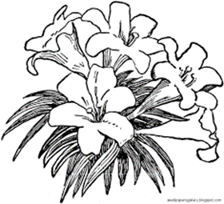

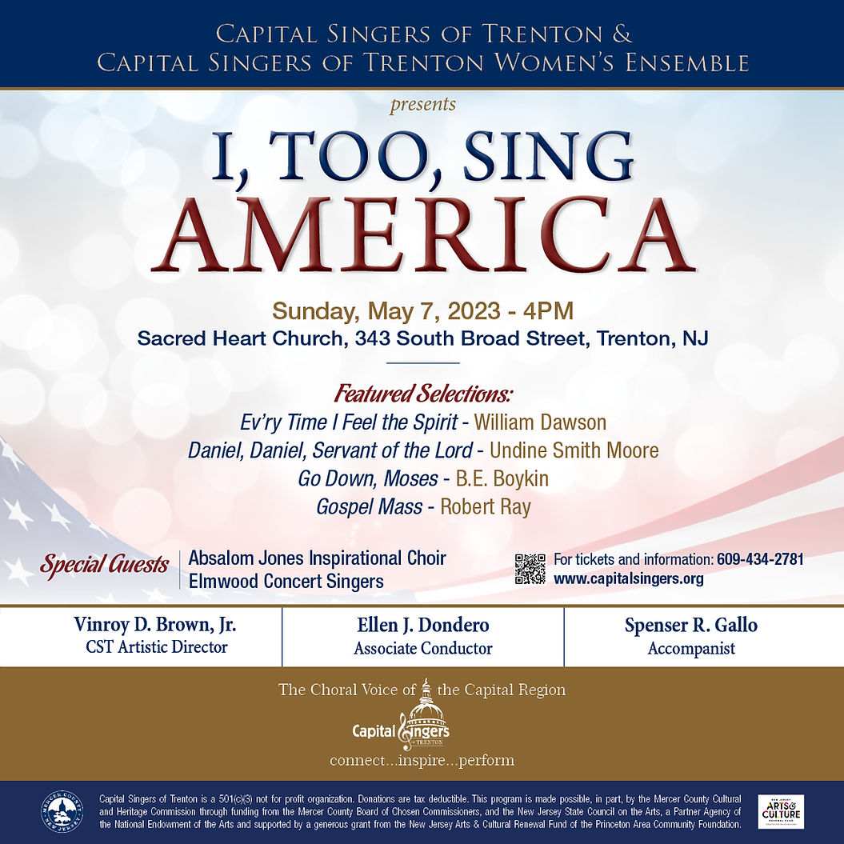
Offerings at Francis House of Prayer
Trenton Diocesan Spiritual Center and Retreat House
84 Walnford Road, Allentown, NJ 08501
609-877-0509 or FHOP@verizon.net Please check www.FHOP.org for dates, registration,
IN PERSON ONLY ~ NOTHING IS SO BEAUTIFUL AS SPRING
Sunday, April 16 1:00 – 4:00 PM
Gerard Manley Hopkins (1844-1889), convert, Jesuit priest and creation mystic used the power of his senses to meet God in nature, and expressed his experience in poetry which is both challenging and consoling. Hopkins saw God working in him as quietly but unceasingly as God works in the growth of flowers and trees. After a brief introduction to the poet’s life and writings, we will delve more deeply into a few poems with time to experience God in the natural beauty that is Francis House. Led by S. Lisa Breslin, SSJ. Donation: $25
PRAYING WITH THE RESURRECTION NARRATIVES
Tuesday, April 18 9:30 AM – 1:00 PM
The Solemnity of Easter comes and goes so quickly, we hardly have a chance to savor its Mystery. We will take a few hours to drink deeply of the hopeful and consoling Presence of Jesus as He appeared to His Apostles and friends and as He continues to manifest His resurrected Presence in our own lives. This will be a wonderful morning of prayer and the true celebration of Resurrection. Led by S. Marcy. Donation: $25, includes lunch; Zoom $20.

Knights of St John Commandery 676 and our Ladies Auxiliary 598
Our Knights of St John Commandery 676 and our Ladies Auxiliary 598 will be hosting members from across New York and New Jersey at the New York Grand Convention commencing May 5-7 at the Crown Plaza Hotel Princeton.

We would very much appreciate your support. Please see the ad order form below. And we would welcome you to join us at the Gala Saturday evening, May 6, at the hotel at 8 p.m. Cost, in advance through the CashApp, is $60. Concluding Mass is Sunday May 7th at 9 a.m. at the hotel. All are welcome.
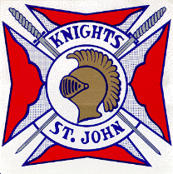
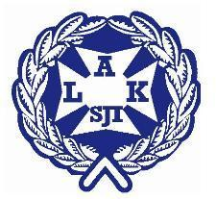
IN GOD WE TRUST
2022 New York Grand Commandery Convention
Program Booklet/ Brochure Ad Order Form

Check one
Full Page |  | $125
Half Page |  | 75
Inside Back/ Front Cover |  | 200
Outside Back Cover |  | 250
Patrons/ Business Card |  | 35

Name: ____________________________ Tel #:_______________
Email Address:________________________
Address:___________________ City: __________________ State: __________ Zip code: ______
(Please send all Ads Electronally to: Sis. Angela Dodson: Email: dodson.angela.p@gmail.com
Please make all checks payable to: KSJI Commandery 676.
Mail check to: Sir Knight Andrew Mowenn
46 Grasspond Road,
Levittown. Pennsylvania 19057
Or CashApp Using: $KnightsOfStJohn676

